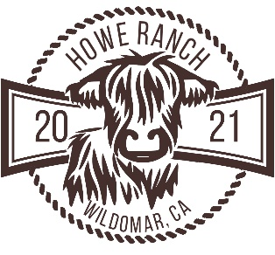

The Enchanted Moments Package
$2,495 $2,895
for 2 - 30 Guests for 31- 50 Guests

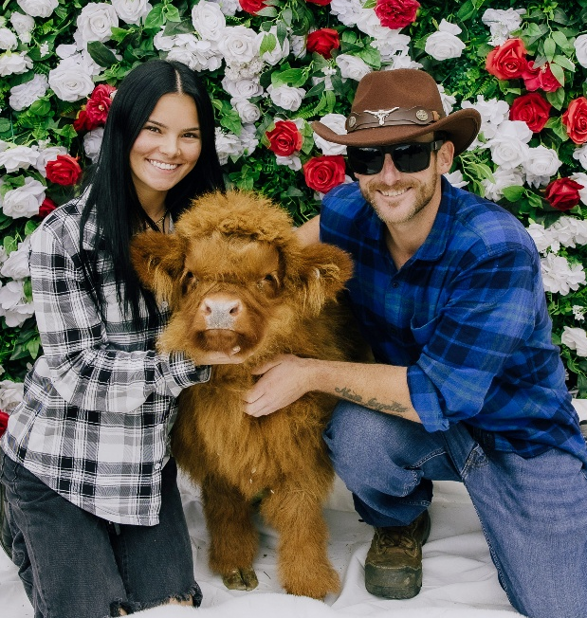

Our Enchanted Moments Package offers a truly special and memorable experience, setting us apart from traditional farm venues. At our farm, guests aren't confined to a single space or two; instead, they journey through multiple unique seasonally themed environments, each offering its own charm and ambiance. From the rustic themed social hour to engaging animal encounters where you can snap pictures with micro- and mini-Highland cows, alpacas, mini goats Baroque donkeys, and other friendly heritage farm animals, the day unfolds seamlessly.

The gathering continues with a picturesque program under mature trees, optionally followed by dining and lounging in additional areas guests can utilize—from a chic poolside gathering to a shaded banquet area surrounded by nature, all against the backdrop of stunning panoramic views. This flow allows you and your guests to enjoy a variety of beautiful features and interactions in one cohesive event, making every moment unforgettable.
All items below are included in the Package unless marked as
Add On.

VENUES & INCLUSIONS

- 1 – 30 Guests – Up to 5 Hours of Venue Use with up to 3 Hours of Guest Hosting
- 31 -50 Guests – Up to 6 Hours of Venue Use with up to 4 hours of Guest Hosting
- Food & Beverage Service Included (details under Catering, p. 5)
- Use of up to 4 Areas plus an Indoor Respite Area
- Use of selected groomed and landscaped spaces on 4 acres
- On-site and accessible Parking
- Restroom with accessible commode and sink in Club Room, Animal Barn Restroom

- Welcome Guests

Animal Encounter with Photos 60 – 90 Minutes
Micro & Mini Highland calves & cows, Donkeys, Alpacas, Mini Goats, Ducks & Chickens

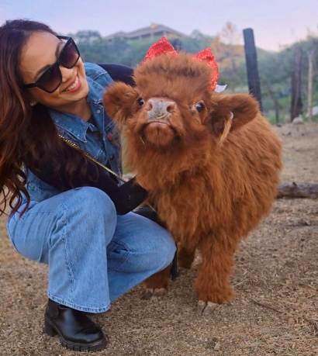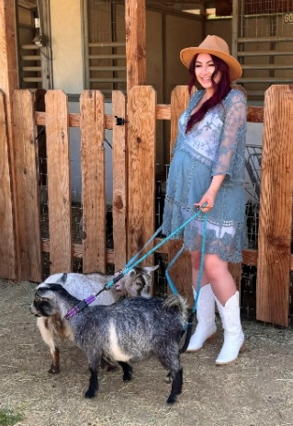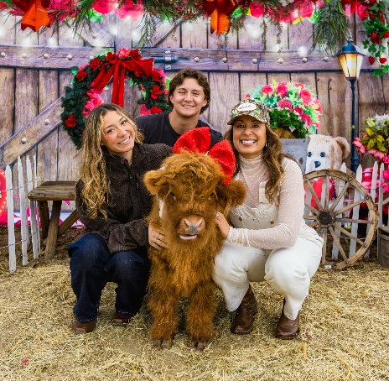

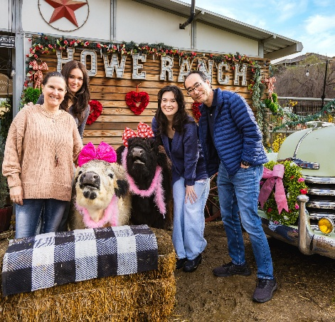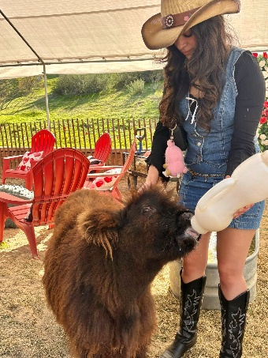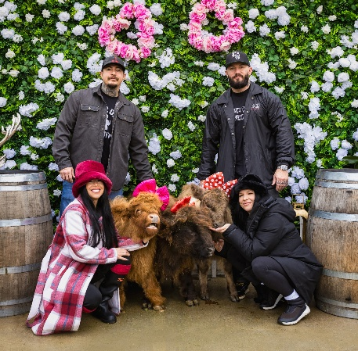

Valley View Terrasse
Guests arrive here (upper property) from the parking and animal interaction areas (lower property)
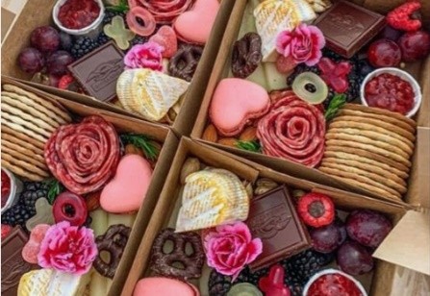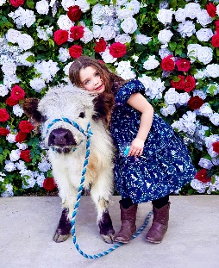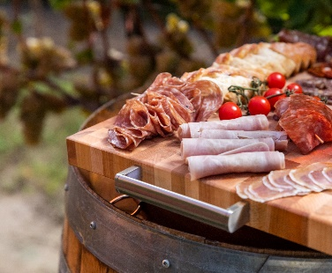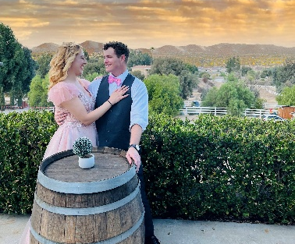

2. Dinner & Retreat

Option A. Sunset Sanctuary with panoramic views

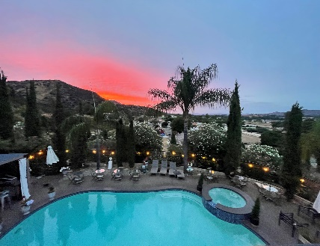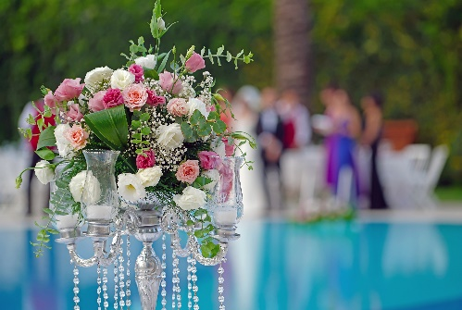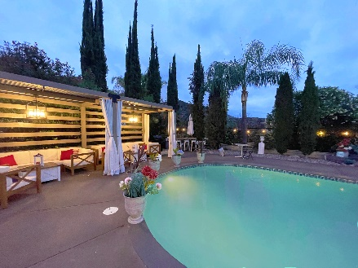
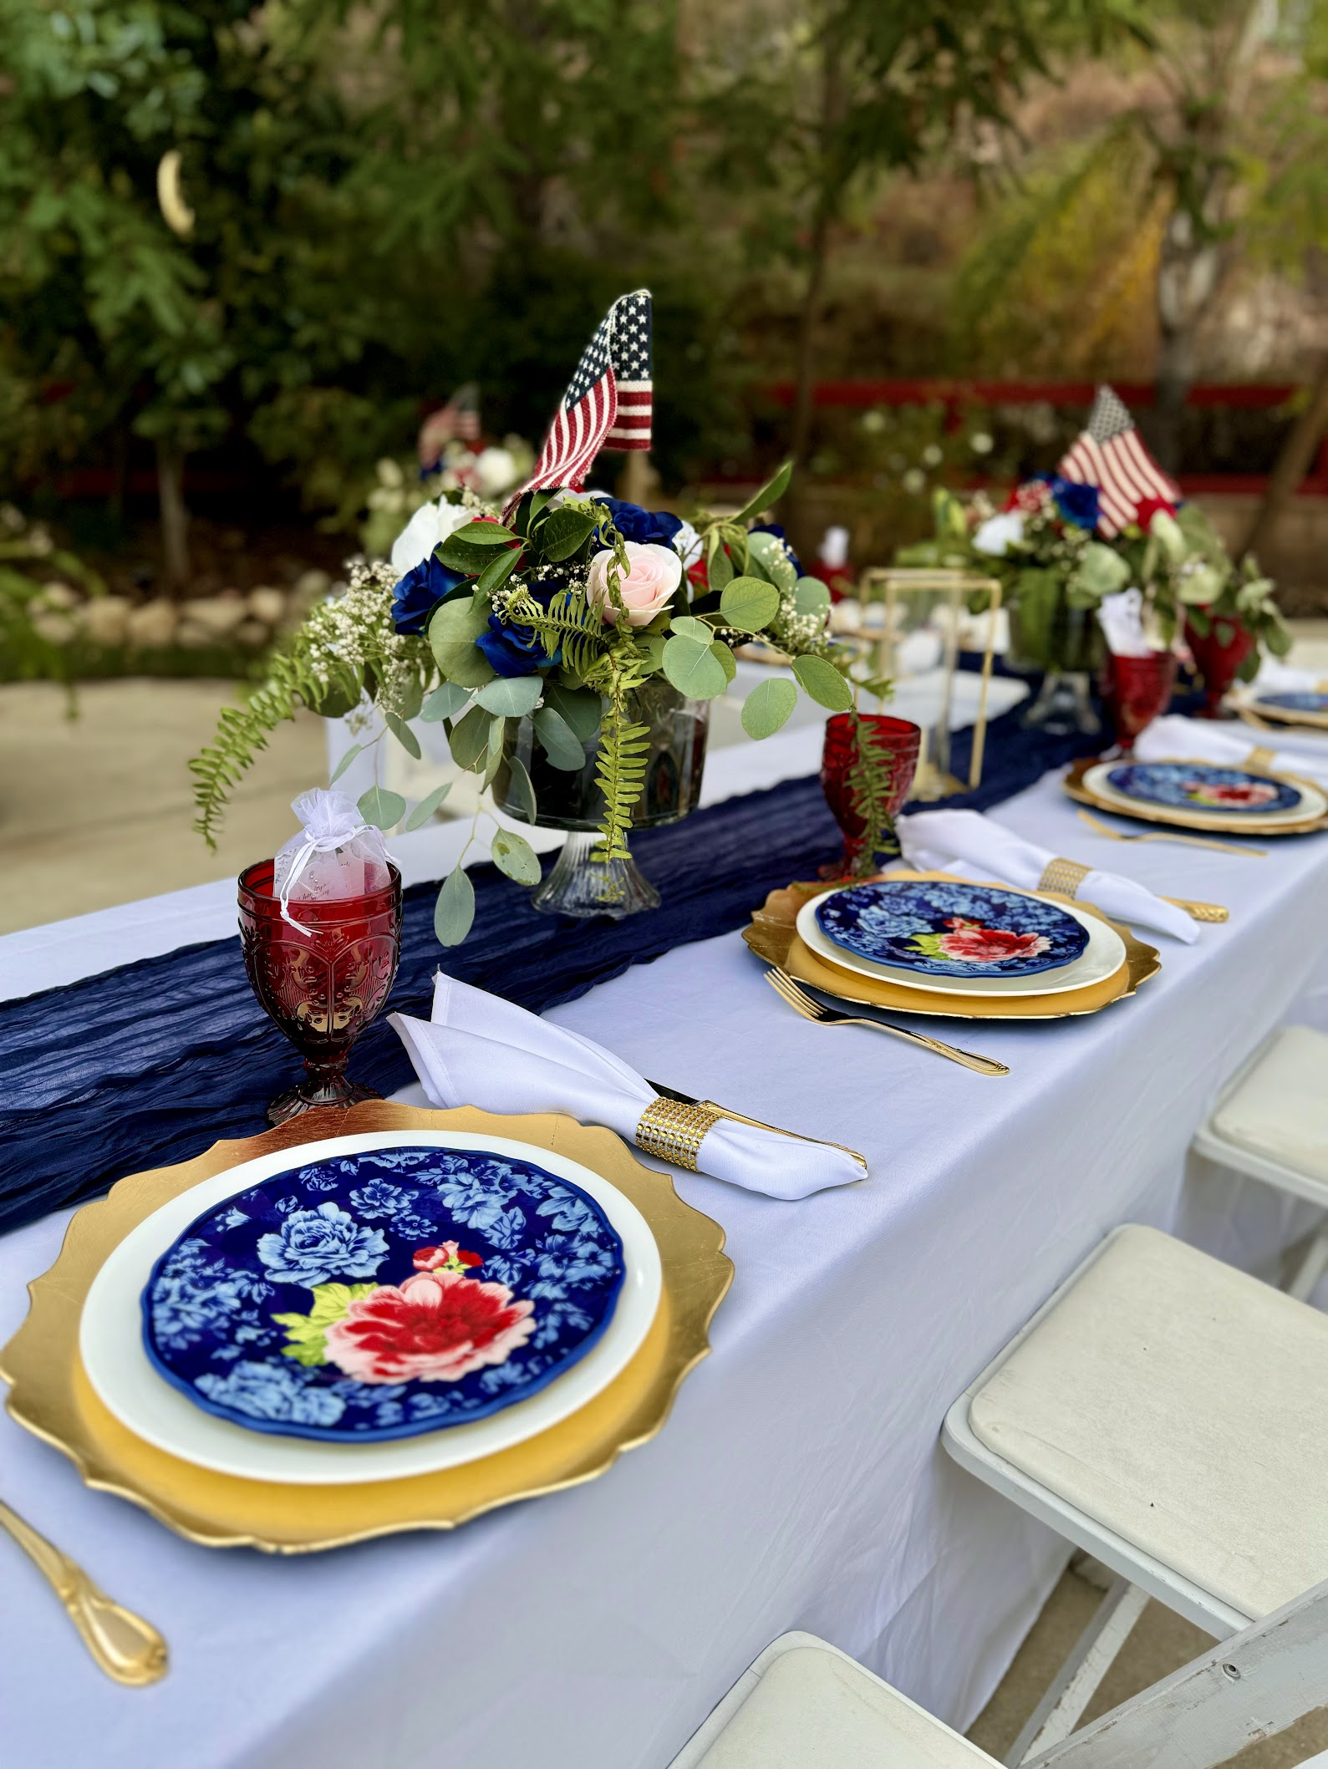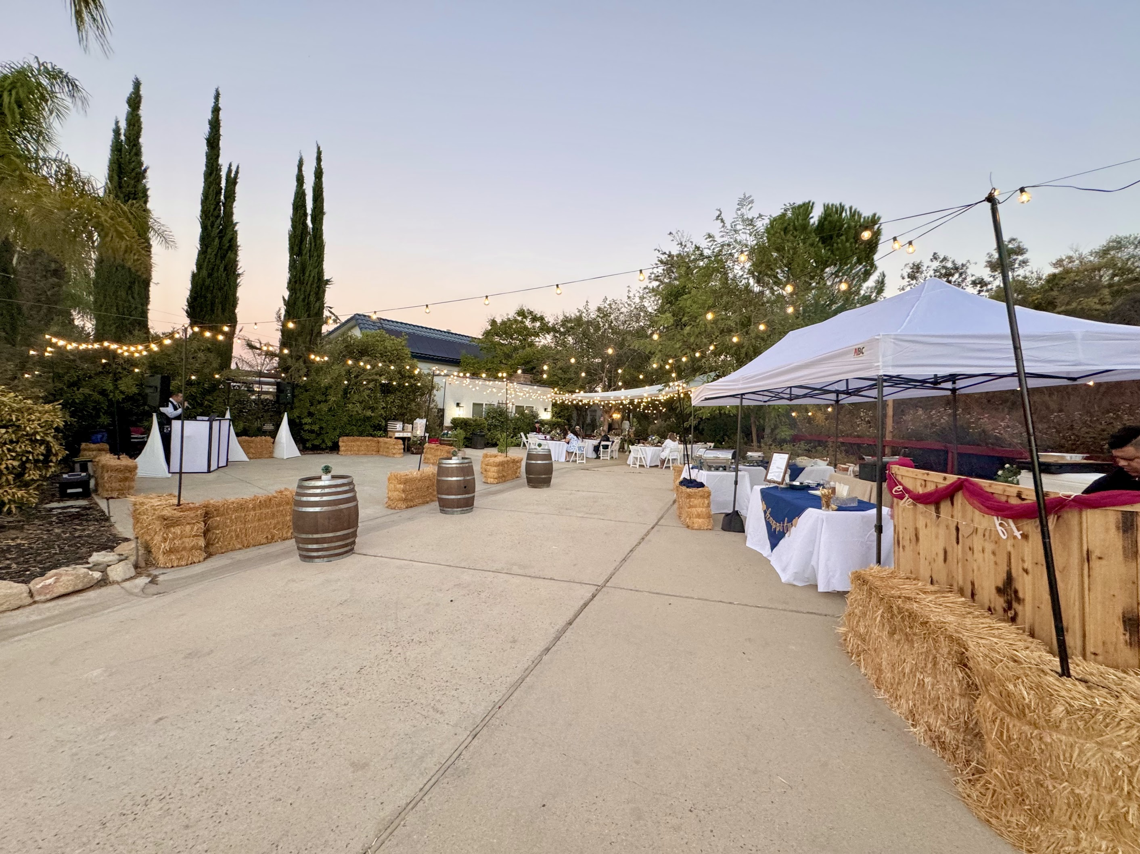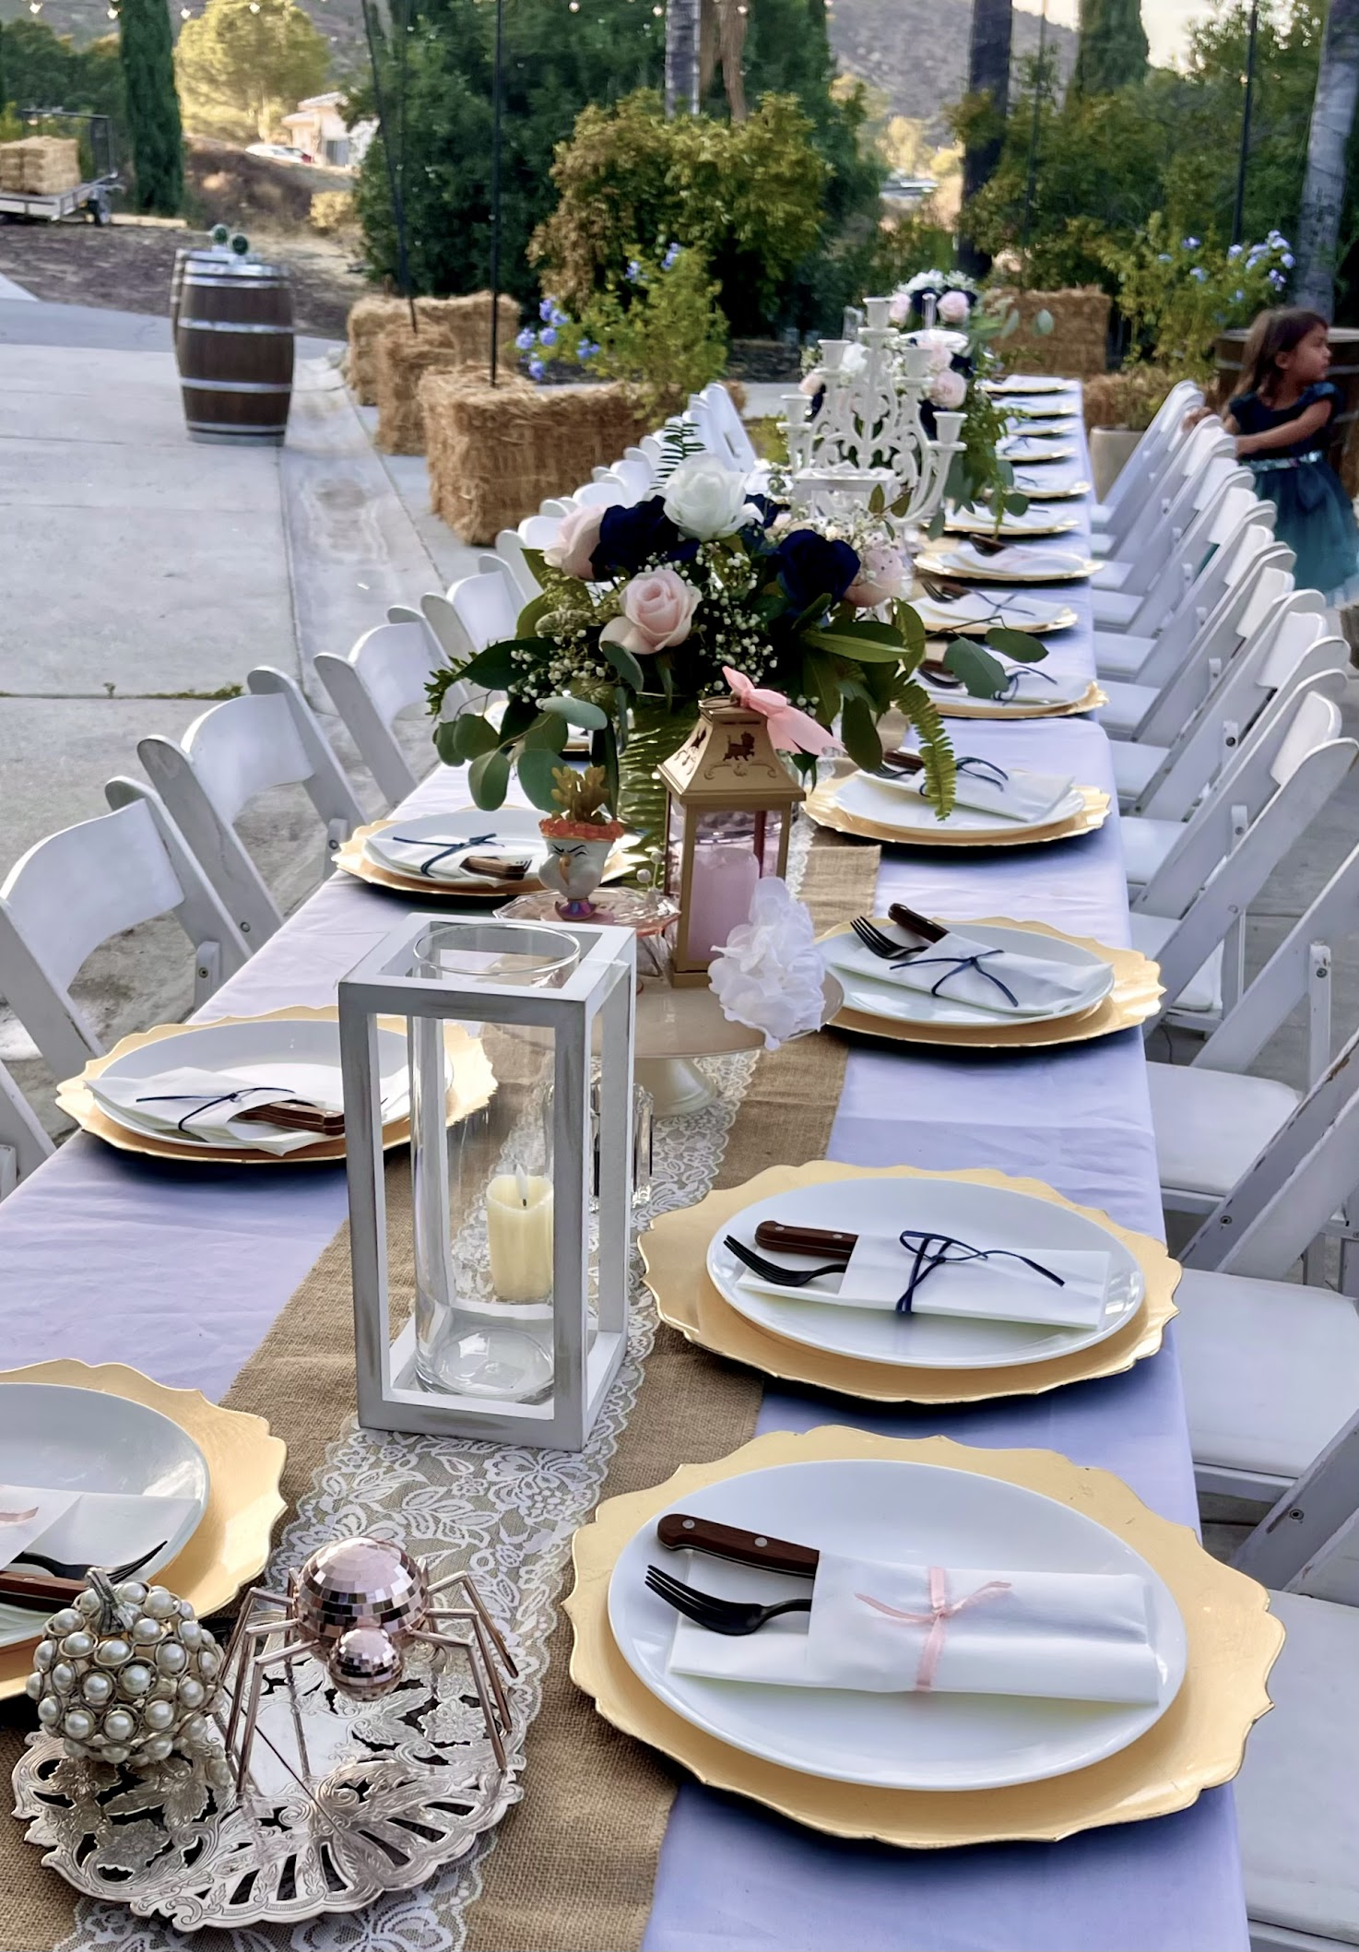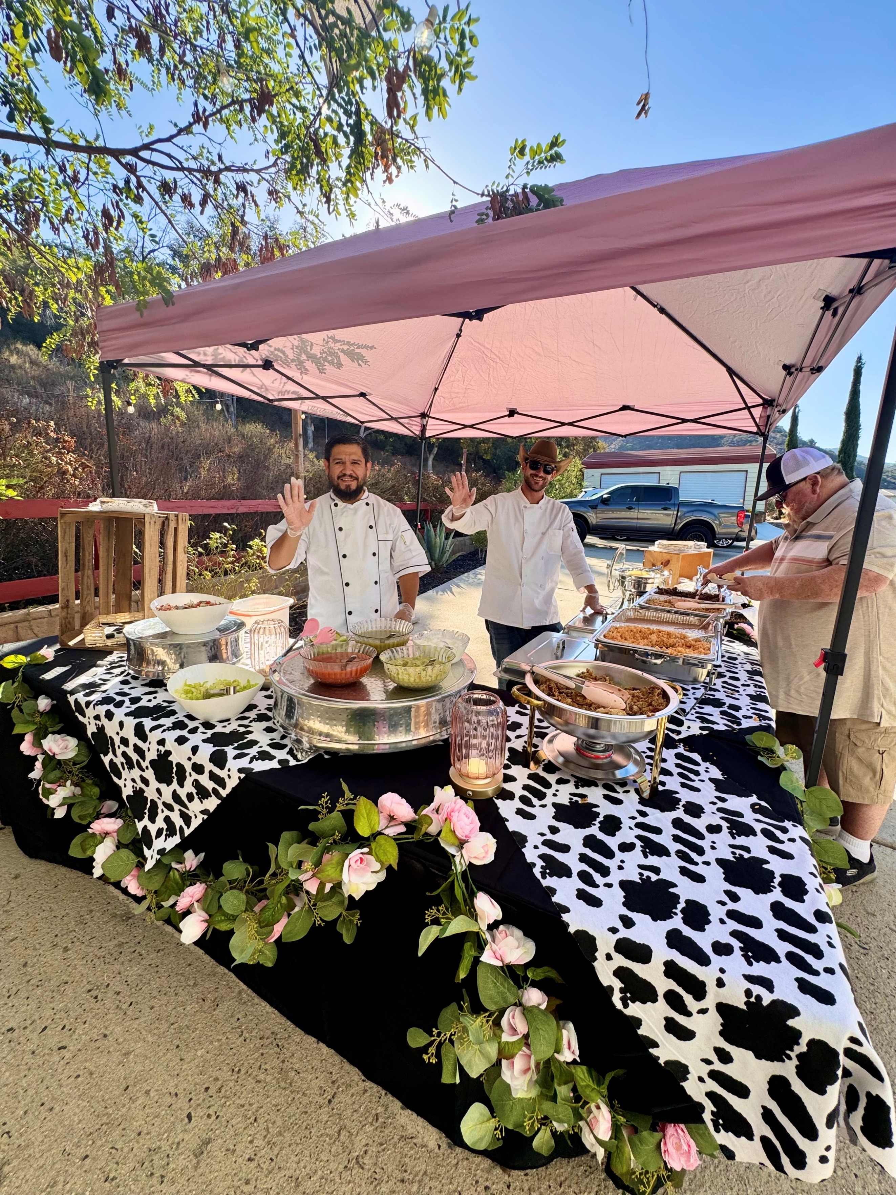
Option B (or combination). The Plaza: Banquet/Dining Area with Catering Buffet and Activity Area

SERVICES INCLUDED

Provision of the following services and amenities for the duration of the event:

1. DÉCOR, SETUP, AND SERVICES:

- Optional:
Styled Welcome Table on Valley View Terrasse, Styled Gift table; Designed Display or other Table in Entertainment Area

- The Plaza:
- Banquet Tables and Chairs for up to 30
- High end Fitted Table linen (black) and burlap table runners
- Customizable centerpiece décor including fresh greenery
- Serving Areas with tables and matching linen (dinner, dessert/cake)
- Ceramic Dinner Plates and plastic or metal flatware (based on availability)
- Design Touches based on Availability

- Sunset Sanctuary:
Cabanas and other shaded seating and lounge areas, hot tub (use and propane heating can be added at $25/hr), unheated pool (designated life guard needed if children use pool), TV, pool toys

- Club Room:
Heated/Air-conditioned respite area with lounge furniture, refrigerator, microwave, big screen TV, games, puzzles, and toys for children, Optional: Highland Cow Coloring Workshop

- Landscaped Photo Opportunities
Photo Sessions can be coordinated with photographer ($350 extra)

- Waste Management
Trash cans provided in all areas; Guests dispose of all event-related consumable waste; Cardboard/packaging/décor brought by guests must be taken off the property by guests

Photo Opportunities on Property

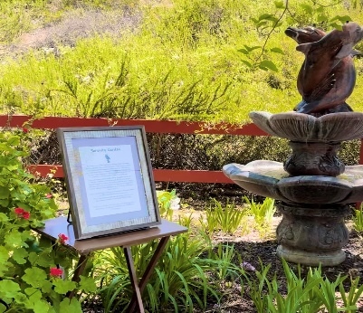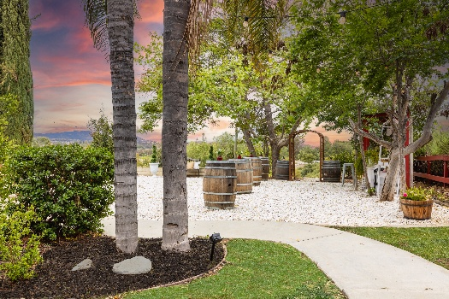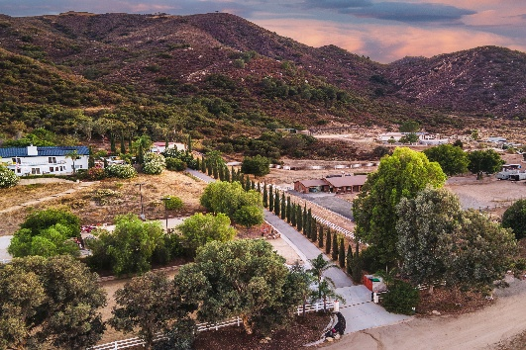

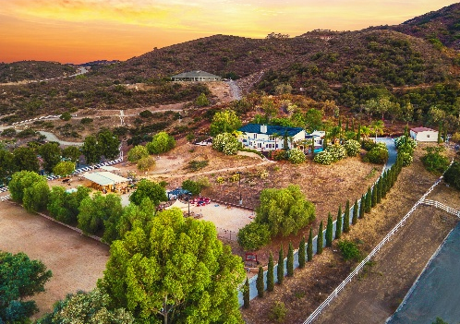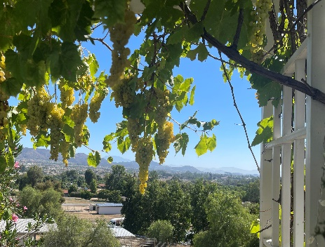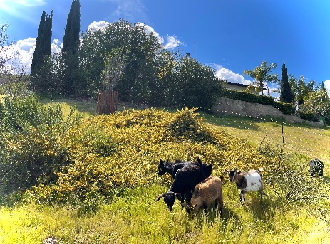

- CATERING
- A Charcuterie Grazing Table is included: Smoked salmon, meat, assorted cheeses, bread, crackers, nuts, fresh and dried fruit

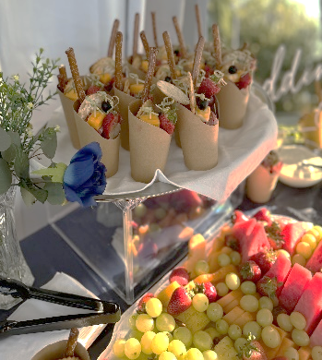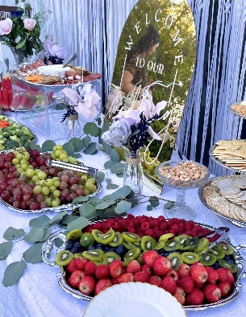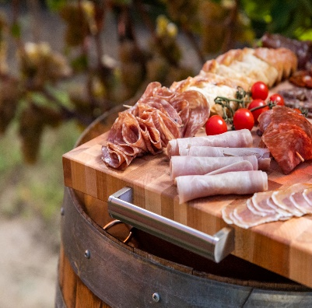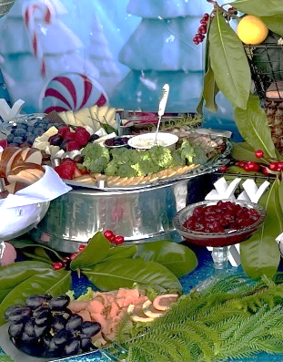

- A Drink Service Station is included: Select up to three drinks (coffee, water, citrus water, iced tea, hot tea, latte, lemonade)

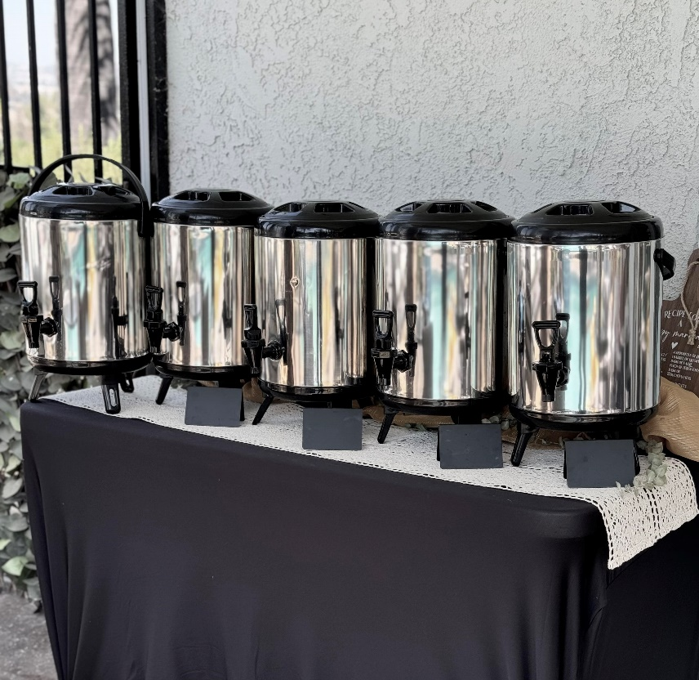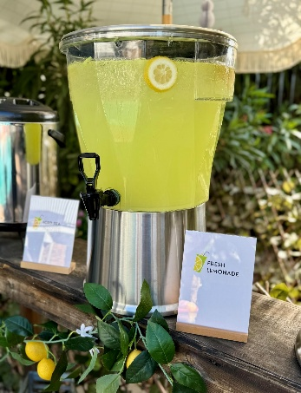

- ADDITIONAL OPTIONS

- Lunch/Dinner:
Option A:
In lieu of Charcuterie Grazing Table: Add $7/Person for Pizza Station (pizza by local preferred vendor)
Or add $12/person for taco bar with 2 meats, sides, guacamole, sour cream, salsas, lime; Provided by top local vendor

Option B:
In addition to Charcuterie Grazing Table: Add $14/Person for Pizza Station
Or add $20/person for taco bar (see above)

- Dessert:
Cookie and Cupcake display: $5/person

ACCOMMODATIONS & PARKING

      - Use of Garden View Suite with Bathrooms by Host (not open to all guests)
- Unlimited Onsite Parking in Lower Lot; Designated with Signage; Note: Parking is on dirt; Strictly no street parking permitted (street is a private dirt road)

STAFF
- Two Onsite Facility Specialists for Day of Event
- Petting Zoo/Hospitality Staff if applicable
LIABILITY & INSURANCE

- The Provider confirms coverage of $1 million in liability insurance and $1 million in personal injury insurance. It is the Client's responsibility to secure appropriate insurance coverage for the event.

GUEST EXPERIENCE GUIDELINES
To ensure a safe, enjoyable, and well-cared-for farm experience for all guests and animals, the following general guidelines apply to all visits and events at Howe Ranch:
Food & Beverage
Outside food and alcoholic beverages are not permitted on the property, with the exception of a celebratory cake. Select concessions, treats, and catering options are available through approved offerings.
Farm Atmosphere
Howe Ranch is a working farm and boutique venue. Sound levels must remain appropriate for a rural, animal-centered setting to ensure the comfort of our animals, guests, and neighboring properties. No hosting, no sound past 8:00 PM.
Animal Safety
All animal interactions are supervised and guided. Guests may only feed or interact with animals during designated, facilitated encounters using approved feed provided by the ranch only.
Guest Responsibility
All guests are expected to follow posted guidelines, supervise children at all times, respect the property, and leave all spaces as they were found.
Arrival & Parking
Guests must follow posted speed limits, arrival and parking instructions to maintain a safe and respectful environment for our rural residential neighborhood.

We hope to see you at our community events! Please stay in touch:


